**NOTRE DAME UNIVERSITY BANGLADESH**



Computer Networks

Project Report

**Submitted to:** Dr. Fernaz Narin Nur (Adjunct Professor)

**Submitted by:**

Shazidul Alam - 0692220005101009

Batch: CSE-19

**Project Title**

Transportation Control Using Server.

**Introduction**

This project simulates a centralized smart transportation system using Cisco Packet Tracer, where a single SBC microcontroller communicates with a server to control four old cars remotely via directional commands (up, down, left, right). The system uses a switch and router to connect components and ensures proper IP management to avoid conflicts.

**Objective**

To simulate a centralized smart transportation system in Cisco Packet Tracer, where a single SBC microcontroller receives input and controls transportation through directional commands via a server without any IP conflicts or remote overrides.

**Tools & Technologies Used**

1. Cisco Packet Tracer

2. SBC-PT Microcontroller

3. 2950-24 Switch

4. Python-code for SBC Scripting

5. Router

6. Server-PT

7. Old Cars

**Network Design and Configuration**

Server connected to switch via wired connection.

Switch connected to SBC microcontroller and router.

Router connected to four old cars via signal lines for remote control.

Unique static IP addresses assigned to SBC and server to prevent conflicts.

**SBC Microcontroller Code**

The SBC is programmed in Python.

Receive USB input commands specifying car ID and direction.

Parse commands to identify which car to control.

Send directional commands to the server, which relays them to the appropriate car.

**Project Workflow**

Server hosts a registration interface to receive and process directional commands.

Microcontroller receives inputs and sends commands to server via USB.

Server communicates through the network to control cars.

Four cars respond to the commands independently without IP conflicts.

**Project Diagram**

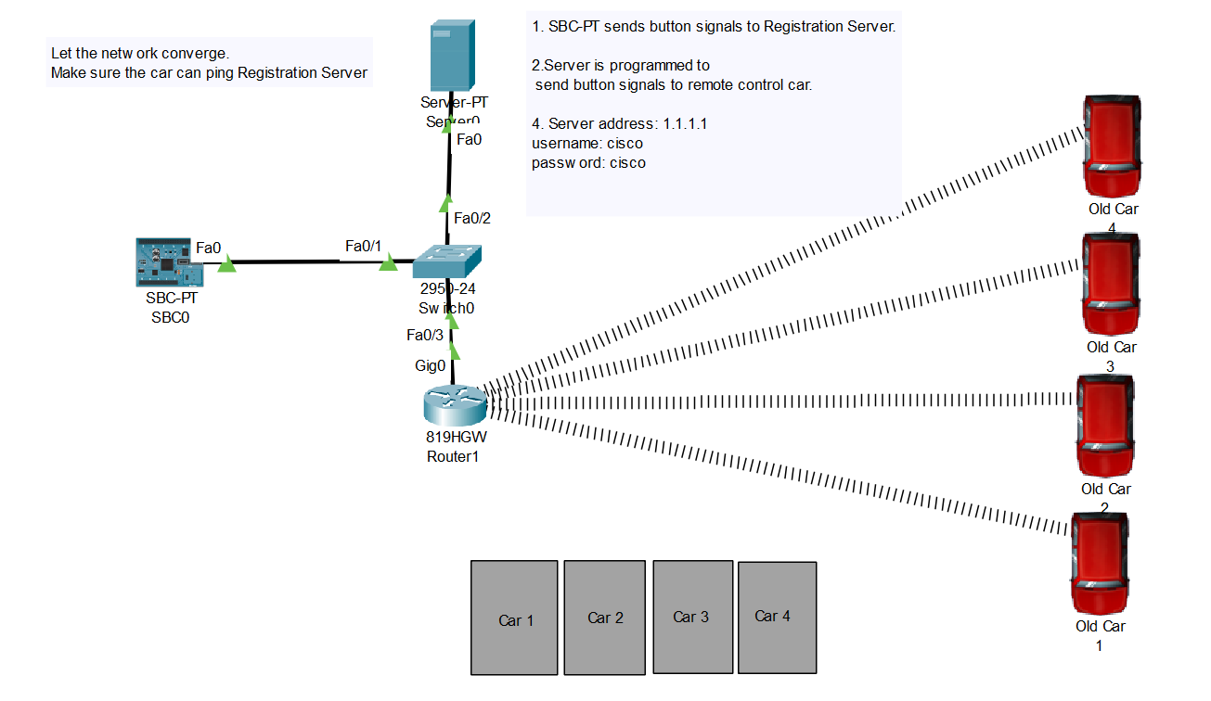

**Microcontroller Code**

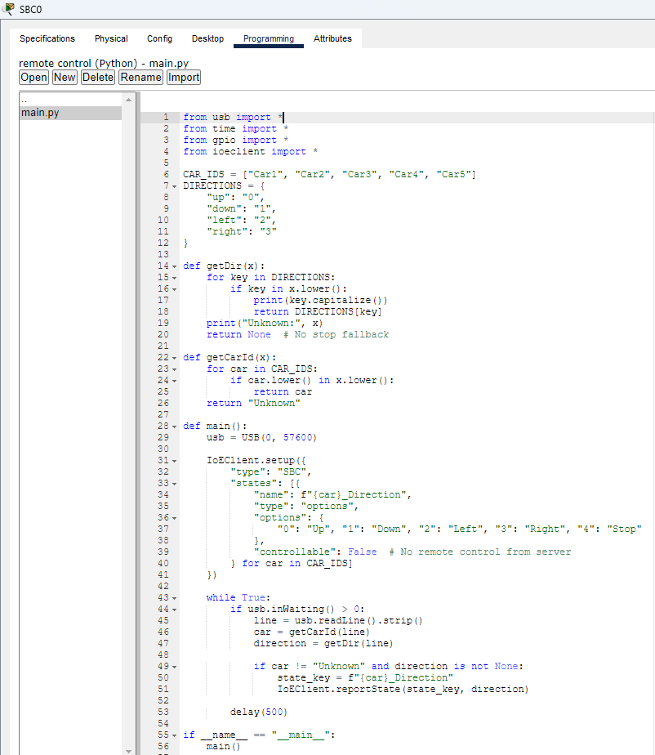

**Router Configuration**

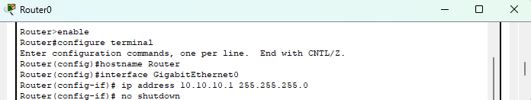

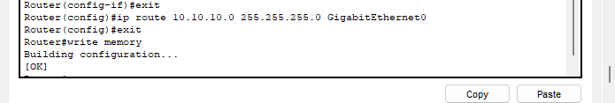

**Transport Control**

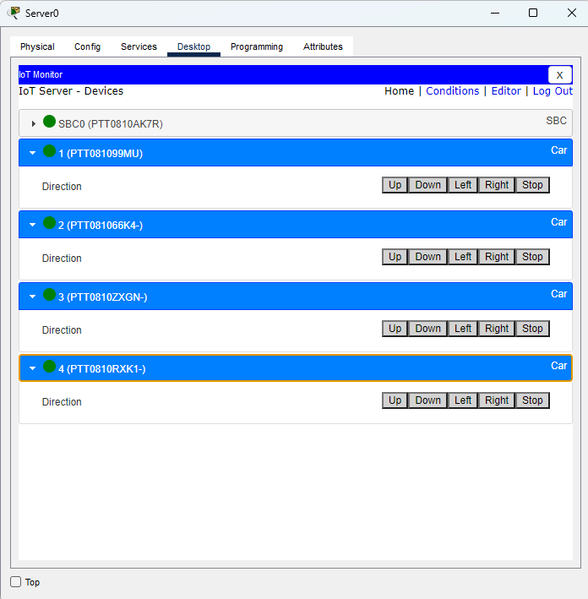

Car 1 Control

Car 2 Control

Car 4 Control

Car 3 Control

**Conclusion**

This project demonstrates how centralized control of multiple vehicles can be simulated using network components and microcontroller scripting in Cisco Packet Tracer, ensuring efficient IP management and secure control with a server.